WEEK 4 – ASSIGNMENT
Azure Cloud Fundamentals and Data Pipeline Implementation using ADF
Objective: To understand Azure cloud concepts and build a complete data pipeline using Storage Account and Azure Data Factory.

Task 1: Azure Portal & Resource Group
Do:
- Explore Azure Portal
- Create a Resource Group
Deliverable:
- Screenshot of Resource Group

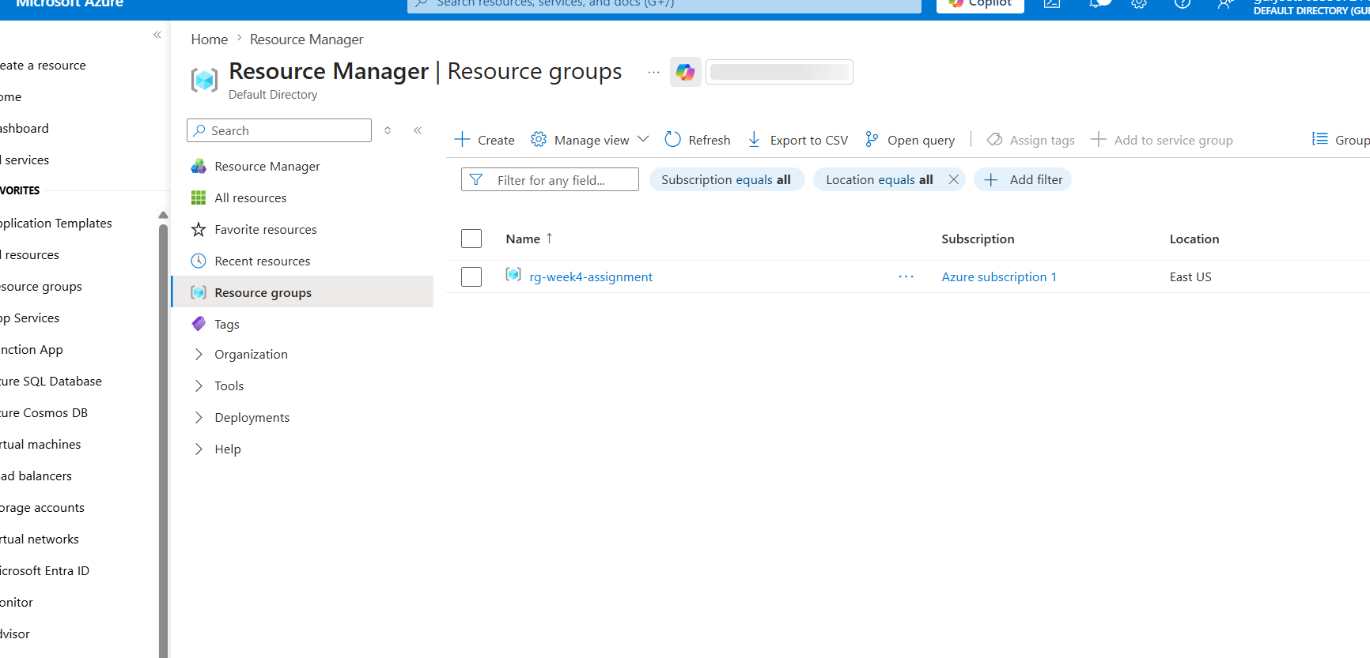
Task 1 Screenshot – Resource Group

Task 2: Storage Setup
Do:
- Create a Storage Account
- Create a Blob Container
- Upload a CSV file
Deliverable:
- Screenshot of container with uploaded file

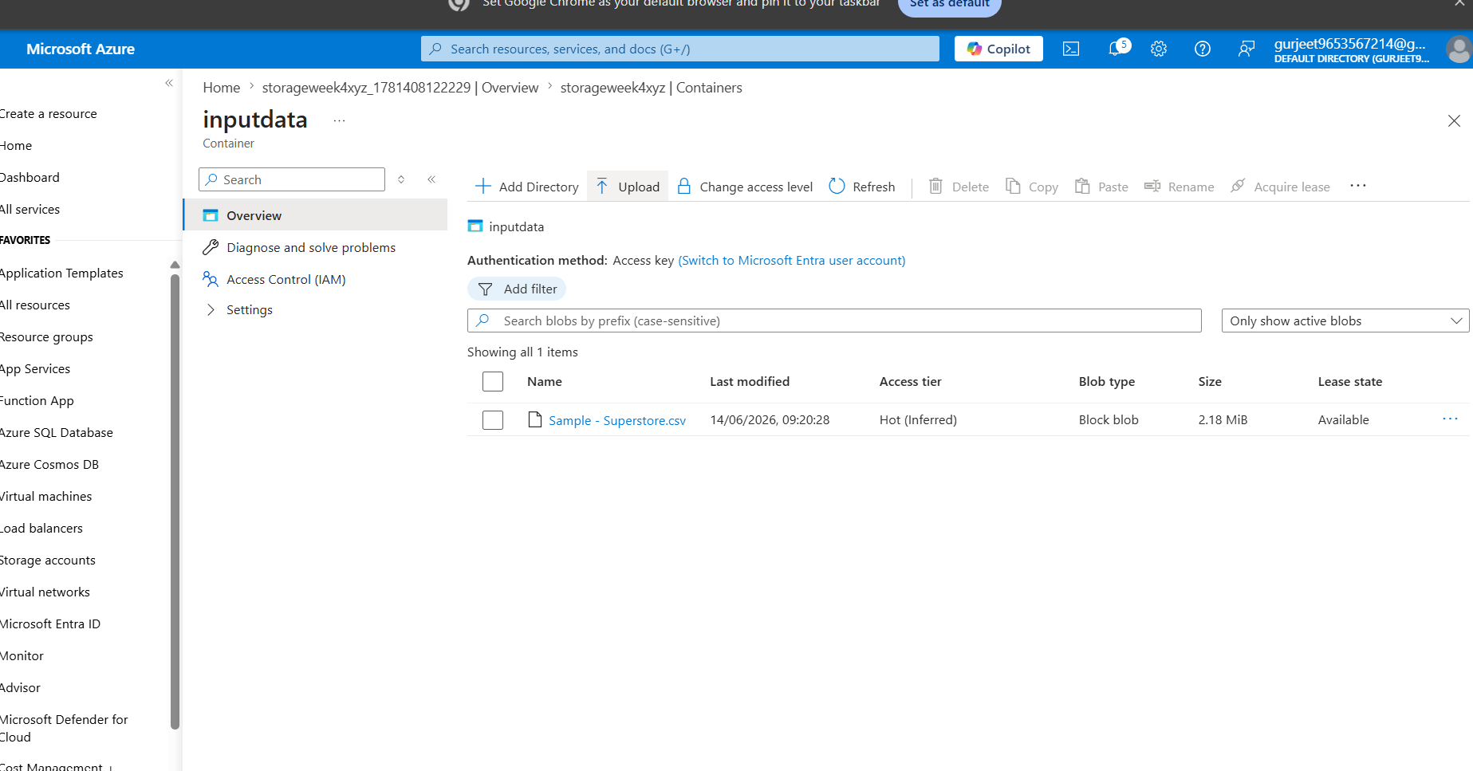
Task 2 Screenshot – Storage Account & Blob Container

Task 3: ADF Basics
Do:
- Create Azure Data Factory
- Explore ADF UI (Author, Monitor, Manage)
- Create Linked Service (Blob Storage)
- Create datasets (source + destination)
- Use Get Metadata activity
Deliverable:
- Screenshot of Linked Service
- Screenshot of dataset
- Screenshot of Get Metadata activity

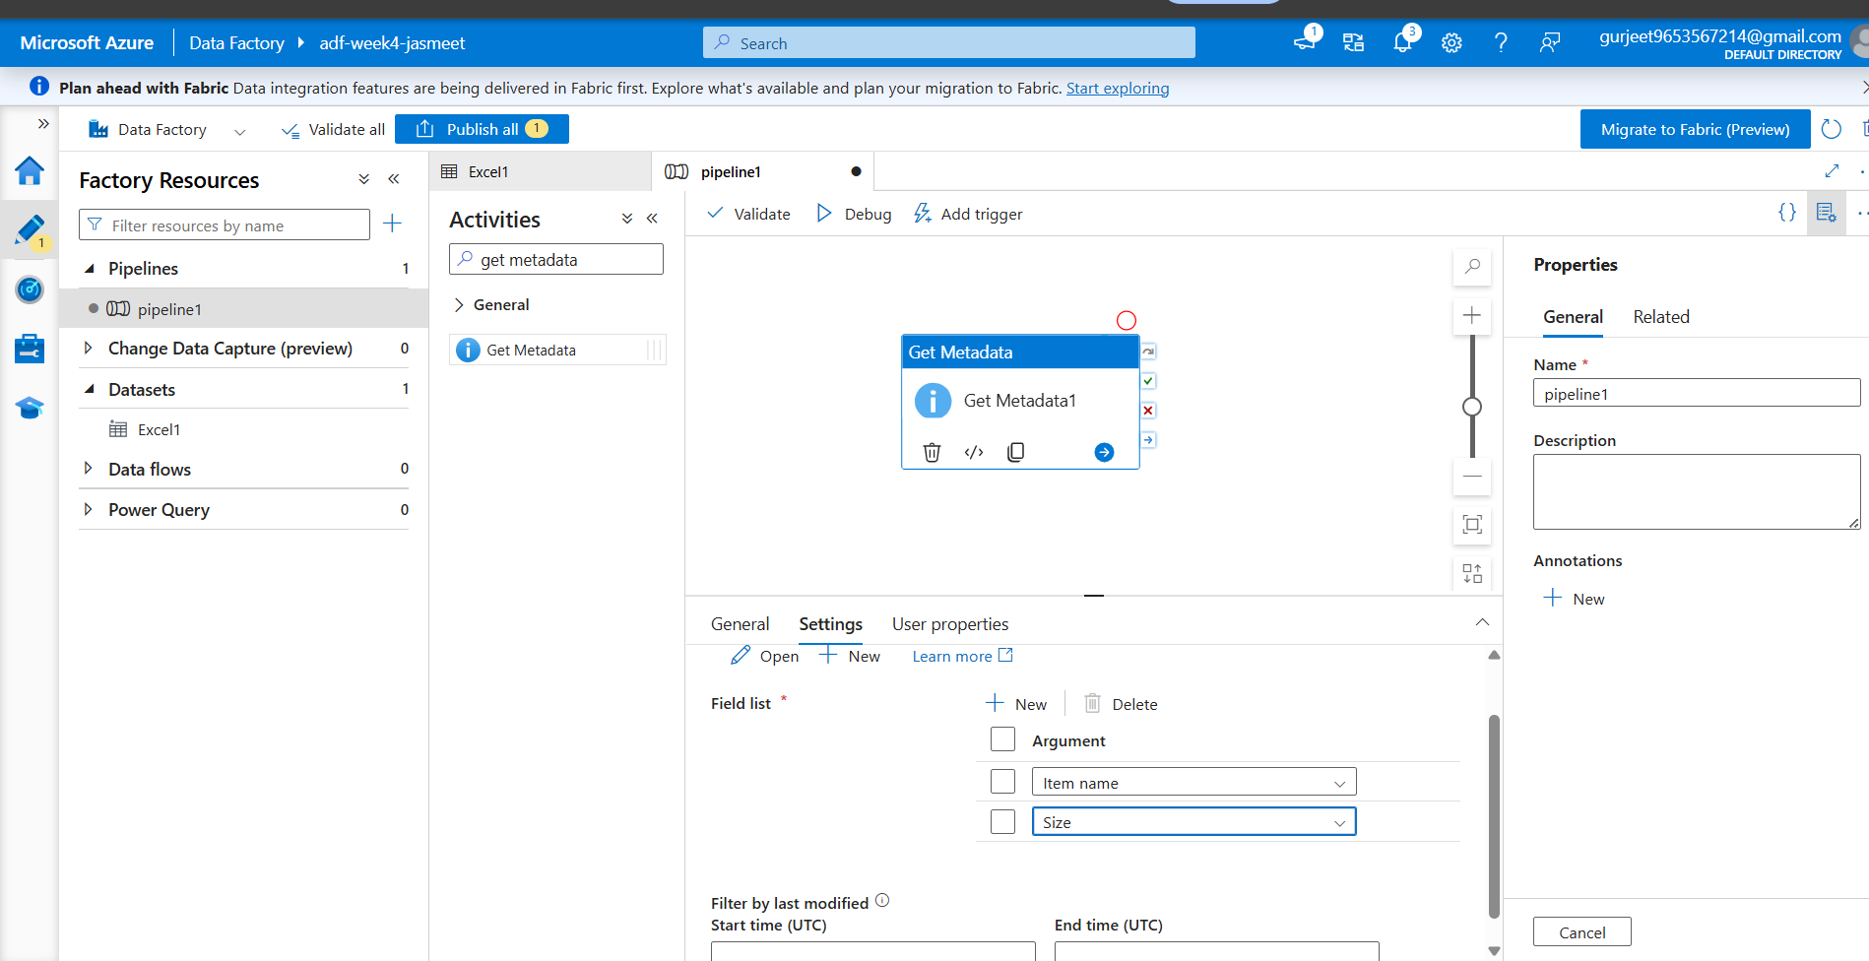
Task 3 Screenshot – ADF Setup

Task 4: Pipeline Development
Do:
- Create pipeline using Copy Data activity
- Configure source and destination
- Add ForEach activity (optional if multiple files)
Deliverable:
- Screenshot of pipeline design

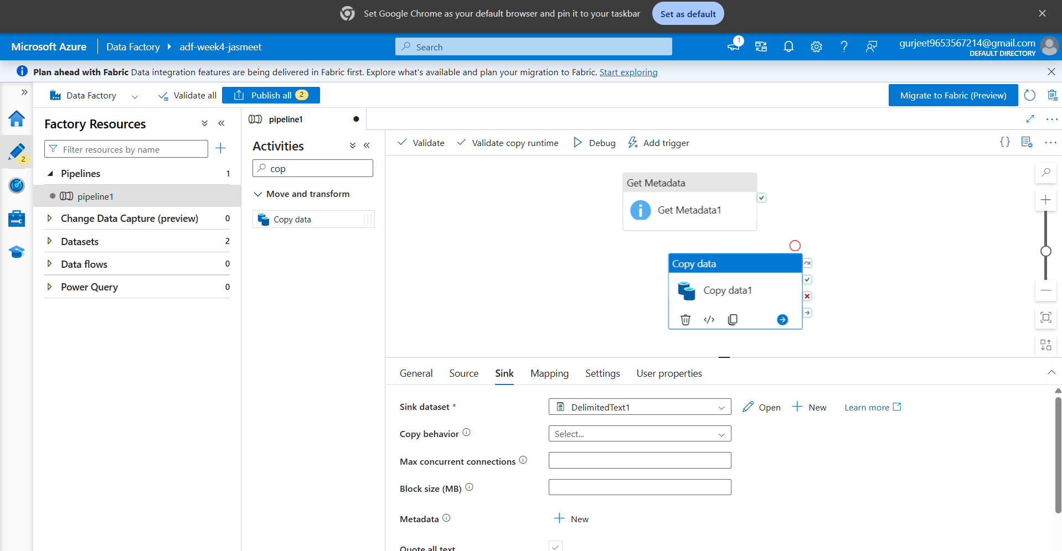
Task 4 Screenshot – Pipeline Design

Task 5: Pipeline Execution
Do:
- Run pipeline using Debug/Trigger
Deliverable:
- Screenshot showing pipeline execution (Succeeded)

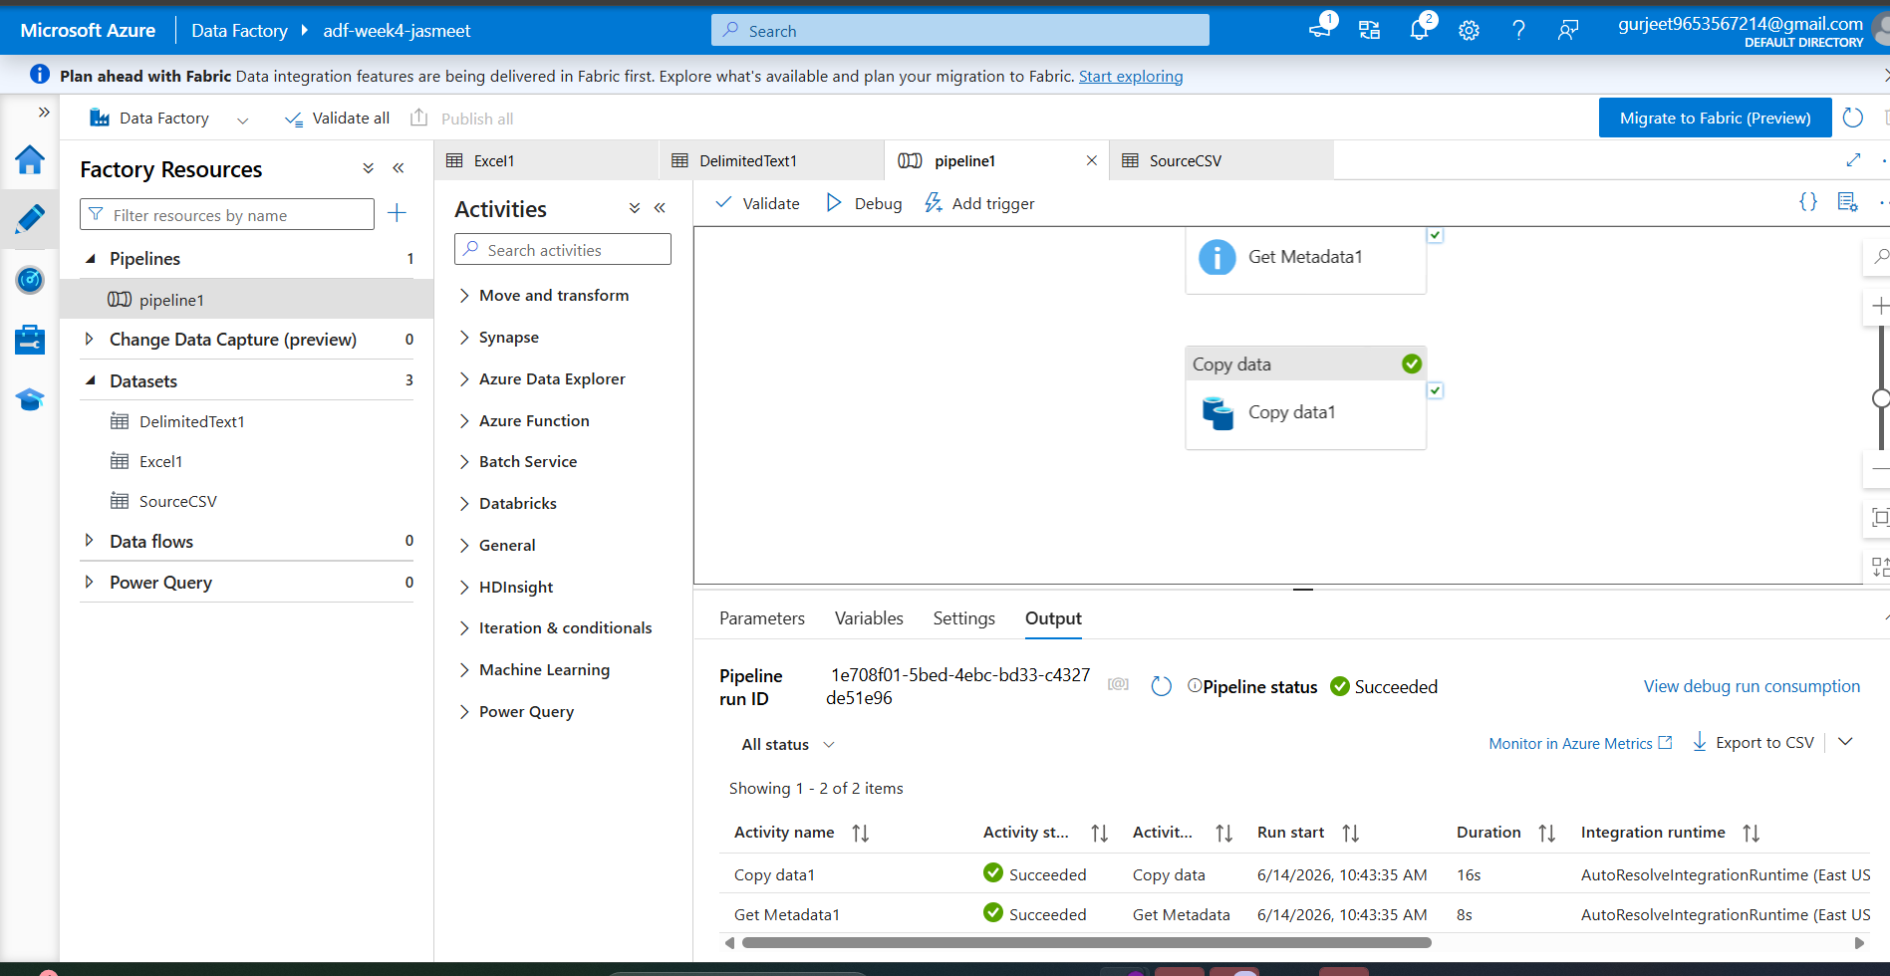
Task 5 Screenshot – Pipeline Execution (Succeeded)

Task 6: IAM Roles
Do:
- Assign roles: Reader, Contributor
- Provide access to ADF for Storage
Deliverable:
- Screenshot of role assignment

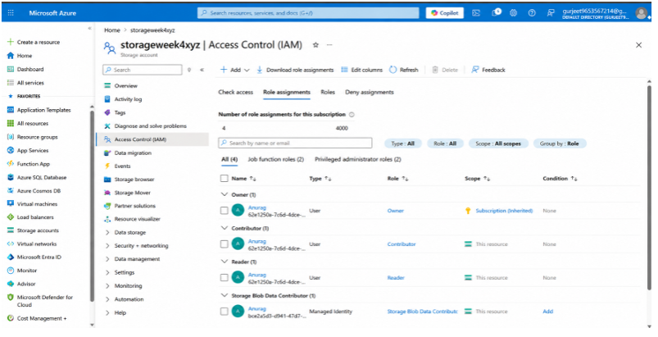
Task 6 Screenshot – IAM Role Assignment

Mini Project (Final Task)

Problem Statement
Build a complete pipeline that reads a CSV file from Blob Storage and processes it using Azure Data Factory.

Requirements
- Source: CSV file in Blob
- Use: Linked Service + Dataset + Pipeline
- Process: Copy Data + Metadata check
- Destination: New file/location

Expected Output
- Pipeline executed successfully
- Data copied to destination
- Metadata validated
Deliverable:

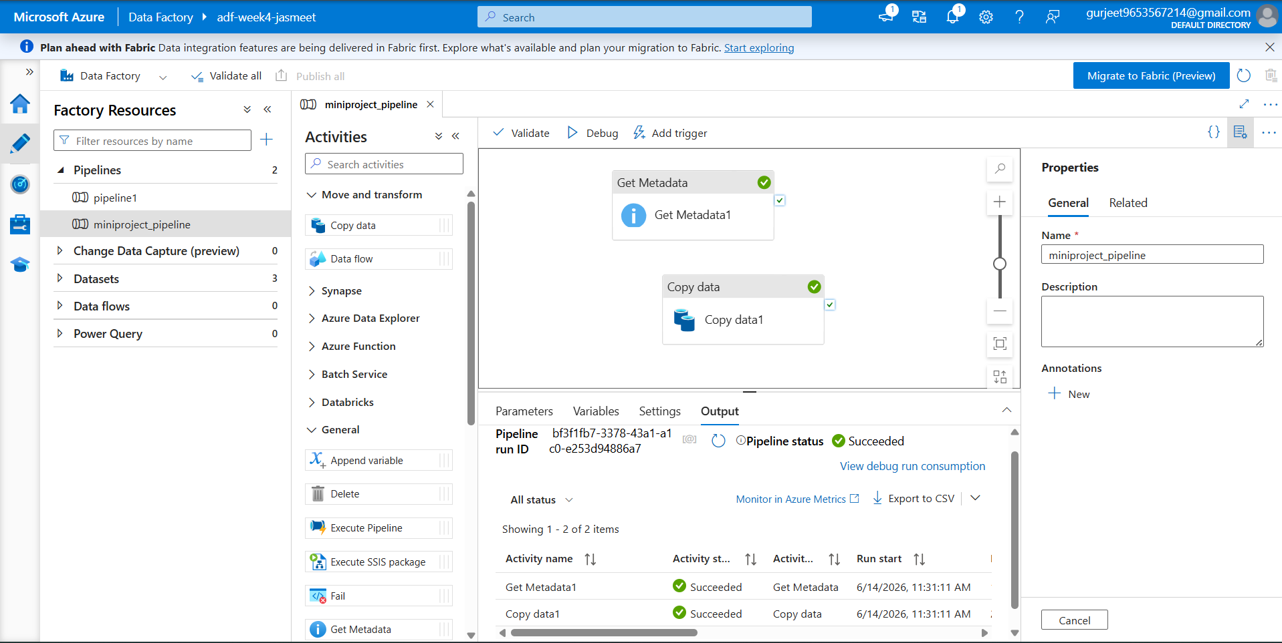
Mini Project Screenshot – Pipeline Execution & Output

